Quadratic equation is nothing but polynomial equation with degree 2.The graph of quadratic equation i.e. represents a parabola.
It is often claimed that Babylonians (about 400 BC) were first to solve quadratic equation. However this is not true, Savasorda in 1145 came with complete solution of quadratic equation about 900 years from then we have many interesting things to calculate like intervals of values of x for which quadratic expression is of
one sign and many more things.
So let us start solving “QUADRATIC EQUATION”
INTRODUCTION:
An equation of form = 0 where a, b, c e C is called quadratic equation.
- If a = 0 then one root is and other root is
- If a=b=0 then both roots are .
In general roots of equation are given by
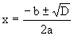
Where is known as Discriminant.
Nature of roots:
1) The quadratic equation has real and equal roots if D=0.
2) The quadratic equation has real and distinct roots if D>0
3) The quadratic equation has complex roots with non-zero imaginary parts if D<0.
4) p+iq is a root of quadratic equation if p-iq is a root of equation.
More:
a) In general if a polynomial equation with all real coefficients has a root p+iq then p-iq will also be root of equation.
b) So, any polynomial equation with all real coefficients will have non-real complex roots in conjugate pairs.
5) If a, b, c Q and p+√q (q is not a perfect square) is an irrational root of quadratic equation then p-√q is also a root.
More:
a) In general if polynomial equation with all coefficients rational has an irrational root p+√q then p-√q will also be a root of equation.
b) So polynomial equation with all rational coefficients will have irrational roots in conjugate pair.
6) If quadratic equation is satisfied by more than two distinct numbers (real or imaginary) then it becomes an identity i.e. a=b=c=0
Illustration 1:
If a+b+c=0 then find the nature of the root of the equation ?
Solution:
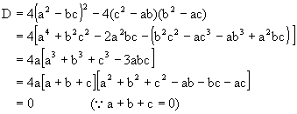
So the roots are real and equal.
Relation between roots and coefficients:
= 0 a ¹ 0, a, b, cÎC, If a,b are roots then a+b = , ab =
Factorization is = a(x-a) (x-b), If a and b are given then equation is
x2-(a+b) x+ab=0.
Illustration 2:
If one root of equation is square of other then find the relation between p and q.
Solution: Let one root be a, so other root is a2
So, a+a2 = -p and a(a2) = q
Now (a+a2)3 = (-p)3
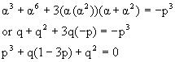
Common roots
If and
1) have a common root, then and common root is given by,
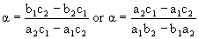
How?
Let a be a common root then
And
Solving we get
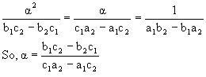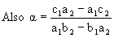
Eliminating a we get
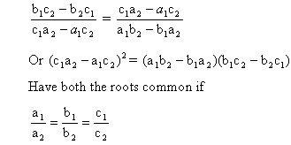
Illustration 3:
Find the condition on a, b, c and d such that equations and have a common root.
Solution: Let a be a common root
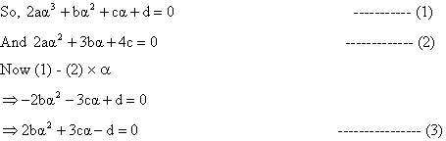
Now from (2) and (3) we find the condition i.e.
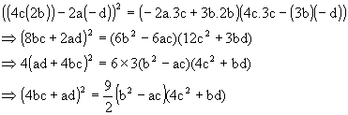
Lagrange’s Identity:
If a1, a2, a3, b1, b2, b3ÎR then,
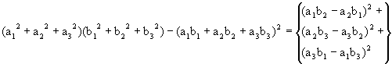
Cauchy Swartz inequality:
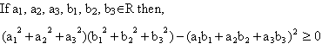
Illustration 4:
If a1, a2, ----------an ÎR+ then show that
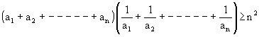
Solution:
Since a1, a2, ----------an ÎR+ so we can take root of each of the ai’s
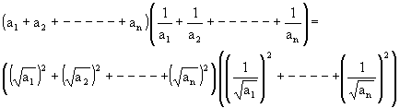
Now using the Cauchy Swartz inequality we get,
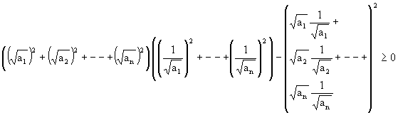
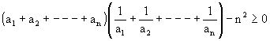
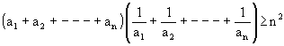
Equation of Higher Degree:
Consider the equation;
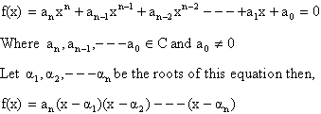
Also,
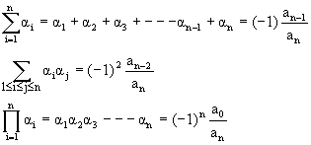
Illustration 5:
and f (0), f (-1) are odd integers then prove that f(x) =0 cannot have all integral roots.
Solution:
f (0) =d, f (-1) = -1+b-c+d
As given in the equation, d is odd and also -1+b-c+d = odd
Or b-c = 1+odd-d
= even-odd
= odd ------------ (1)
So,d and b-c are odd
Now let a, b, g be integral roots

abg are 3 integers whose product is odd.
So, a, b, g are odd.
Again ab+ga+bg = c
And a+b+g = -b
Now b and c will also be odd and so b-c will be even which contradicts (1).
So roots cannot be all integers.
Wavy Curve Method:
Let where and are fixed numbers satisfying the condition, First we mark the numbers on the real axis and the plus sign in interval of the right of the largest of these numbers i.e. on right of an. If kn is even, put plus sign on left of an otherwise put minus sign.
Now in next interval the sign is put according to this rule: When passing through a_{n-1}
f (x) changes sign if is odd number otherwise it has same sign. Similar rule is applied for the next interval and so on.
Union of all intervals with plus sign give solution of f (x)>0 and solution of f (x) <0 is union of all intervals in which we put the minus sign.
Illustration 6:
Solve the inequality
Solution:
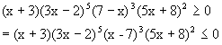
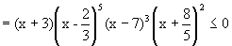
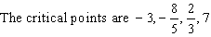
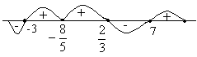
Fig (1)
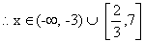
Sign of quadratic expression:
The expression f(x) = y = , a ¹ 0, a, b, cÎR can be written as
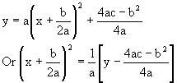
Which represents a parabola with vertex 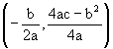 and axis 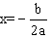
:
1) If a>0
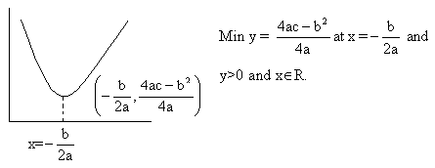
Fig (2)
2) If a<0
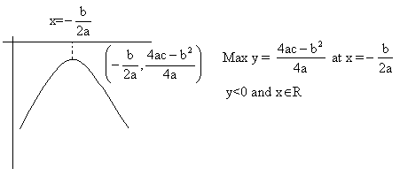
Fig (3)
1) If a>0
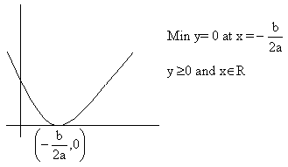
Fig (4)
2) If a<0
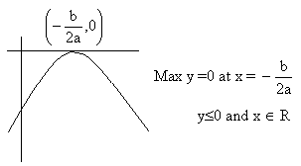
Fig (5)
1) If a>0
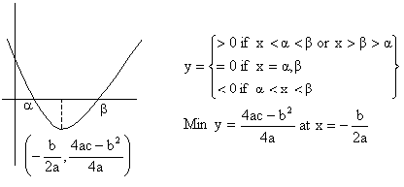
2) If a<0
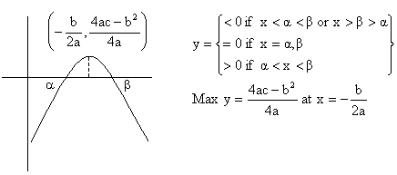
Illustration 7:
Find the condition so that function 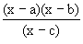 will assume all real values?
Solution:
y =
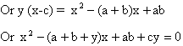
Now the determinant D of this equation must be greater than zero for all values of y
Now in this equation A>0 so B2-4AC should be less than zero i.e. B2-4AC<0 for this condition to hold
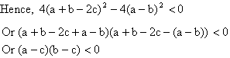
i.e. c lies between a and b.
So, a<c<b if a<b
Or b<c<a if b<a.
Intervals of roots
Let , a ¹ 0, a, b, cÎR and a>0 suppose k, k1, k2, p, qÎR and k1<k2 then
1) If D³0, f (k)>0 and 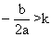 then both roots of f (x) = 0 are greater than k why?
a>0 and D³0
\Shape of parabola is like this
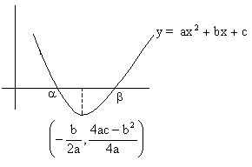
Fig (8)

Now , so k is on left hand side of the point 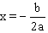
Also f (k)>0, so it is possible only when k<a.
So,a, b>k.
1) If D³0, f (k)>0 and 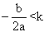 then both roots of f (x) =0 are less than k. Why?
As D³0 and a>0 so shape of parabola is like this
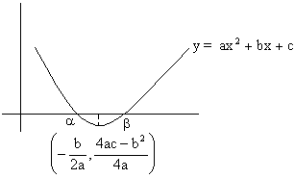
Fig (9)
Now f (k)>0 so k>b or k<a
And also
So, k<a is ruled out
Therefore k>b
Hence, k>a,b.
2) If D>0 and f (k) <0 then k lies between root of f (x) = 0 why?
D>0 and a>0
So the shape of parabola is
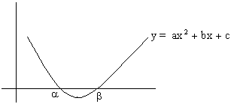
Fig (10)
Now f (k) <0, so clearly a<k<b.
4) If D>0 and f (k1)´f (k2) <0, then exactly one root of equation f (x) = 0 lies in interval (k1, k2). When (k2>k1) Why?
Since f (k1)´f (k2) <0
So, f (k1) and f (k2) should be of opposite sign.
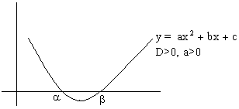
Fig (11)
1) Now let f(k1)<0 and f(k2)>0
So, a<k1<b and k2>b (because k2>k1)
And hence b lies in interval (k1, k2).
2) Second case is f (k1) >0 and f (k2) <0
So, a< k2<b and k1<a (because k2>k1)
Hence a lies in interval (k1, k2).
So exactly one root lies in interval (k1, k2).
5) If D³0, f (p)>0 and f (q)>0, q>p then both the roots of the equation f(x) = 0 will
lie between p and q, if 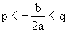 why?
Suppose both roots lie in interval (p, q)
Now D³0, a>0 therefore shape of parabola is
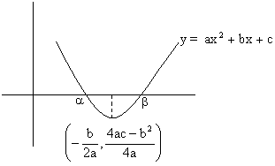
Fig (12)
a, b lies in interval (p, q)
So, b<q and p<a
And hence p<a<b<q
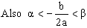
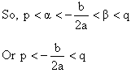
6) If D³0, 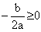 and then both roots of the equation f(x) = 0 are positive. Why?
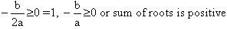
Also 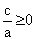 so, product of root is positive, and hence clearly both roots are positive.

Illustration 8:
For what values of ‘a’ exactly one root of the equation lies between 1 and 2.
Solution: Since exactly one root of given equation lie between 1 and 2,
So f (1)´f (2) <0
Here f(x) =
So, f (1)´f (2) <0
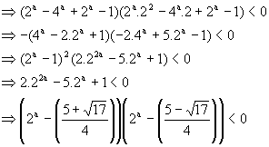
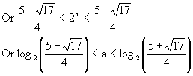
Some important results using differentiability:
1) If f(x) = 0 has a real root a of multiplicity g (g>1) then f(x) = (x-a)gg (a) where g(a)¹0. Also f(x) = 0 has a as a real root with multiplicity (g-1)
2) If f(x) = 0 has n real roots then f (x) = 0 has (n-1) real roots.
Illustration 9:
A polynomial p(x) has as one of the factors, other roots of this polynomial lie in the range 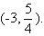 Prove that g(x) where g(x) = p1(x) has at least one positive root.
Solution:
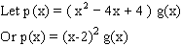
Now p(x) has a root 2 with multiplicity 2.
So the derivative of p(x), p1(x) or g(x) must has 2 as root with multiplicity 2-1=1.
So g(x) has at least one positive root which is 2.
Easy (Quadratic)
Q-1: The roots of the quadratic equation are a and b2 Where 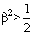 then Show that has roots (a+ib)100 and (a-ib)100
Solution:
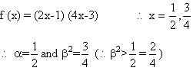
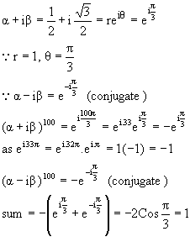
Product = 1.
Required equation is
Q-2: If a, b are the roots of the equation then prove that 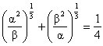
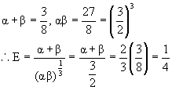
Q-3: If 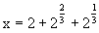 then find value of expression .
Solution:
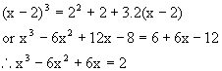
Q-4: Solve the equation
Solution:
Since x=0 is not a solution of given equation. Dividing by x2 in both sides of (1) we get,
Putting 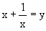 in equation (2) then (2) reduces in the form,
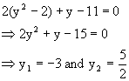
Consequently the original equation is equivalent to the collection of equations,
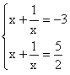
We find that
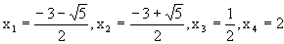
Q-5: If aÎz and the equation (x-a) (x-10) +1=0 has integral roots, then what is the value of ‘a’?
Solution:
As both x and a are integers and hence given equation implies that either x-a =1 and x-10= -1 or x-a = -1 and x-10=1.
x=9 and hence a=8 or x=11 and a=12.
Therefore possible values of a’s are 8, 12.
Q-6: Find the values of ‘a’ for which inequality is true for at least one 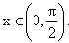
Solution: The required condition will be satisfied if – The quadratic expression (quadratic in tanx).
1) f (x) = has positive discriminant and ,
2) At least one root of f(x) =0 is positive as tanx>0, for all
For (1) discriminant >0
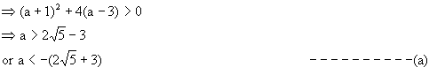
For (2) we first find the condition, that both the roots of
(t=tanx) are non positive for which,
Sum of roots<0, product of roots 0
- (a+1) <0 and – (a-3) 0 -1 <a 3
Condition (2) will be fulfilled of a -1or a>3 - - - - - - - - - -(b)
Required value of a is given by intersection of (a) and (b)
Hence
Q-7: Solve the equation- where (x) and [x] are the integer just less than or equal to x and just greater than or equal to x respectively.
Case 1: If x I,
Then (x) = [x] - - - - - - - - (1),
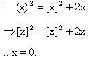
Case 2: if x l
Then (x) = [x]-1
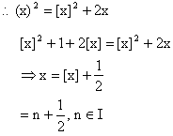
Hence the solution of original equation is, x=0, 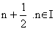.
Q-8: If the equation has real roots a, b, c being real numbers and if m and n are real number such that m2>n>0 then prove that the equation has real roots.
Solution: Since roots of the equation are real
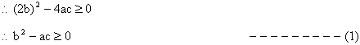
and discriminant of
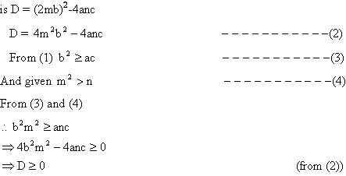
Hence roots of equation are real.
Q-9 If graph of function is strictly above the x-axis then show that -15<a<-2
Solution: Y has to be positive
16x2+8(a+5) x-(7a+5) = +ve
Since sign of first term is +ve therefore the expression will be +ve if D<0.
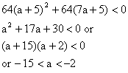
Q-10: For real roots what is the solution of the equation
Solution:
Divide by 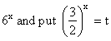 where t is +ve being exponential function.
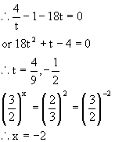
The other value 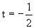 is rejected as t is +ve.
Q-11: Obtain a quadratic expression in x and solve for it if
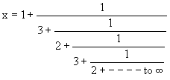
Here 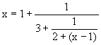

Because,
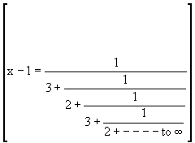
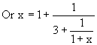
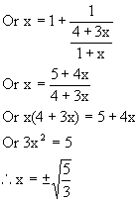
But clearly x is positive
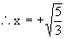
Q-12: Solve for x
Solution: Here A.M of {x-1, x-5} =A.M of {x-2, x-4} =x-3, put x-3=y then,
x-1= y+2, x-2=y+1, x-4=y-1, x-5=y-2.
The equation becomes,
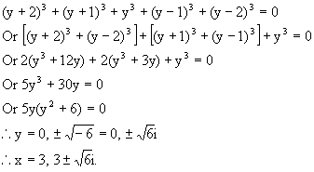
Medium
Q-1: Prove that has no integral solution
Solution: Let then the equation is
As u, v are integers, >1402
But 37² = 1369, 38² = 1444
Minimum possible value of v=38.
Also
v must be even.
Let v=38+2k where k N
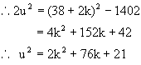
Hence D=0
i.e. which is incorrect.
u, v cannot have positive integral solutions.
So, x, y cannot have integral solutions.
Q-2: If a, b are the roots of and also of and if 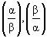 are the roots of then prove that n must be even integer
Solution:
Sincea, b are the roots of
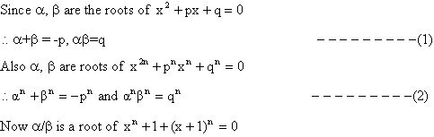
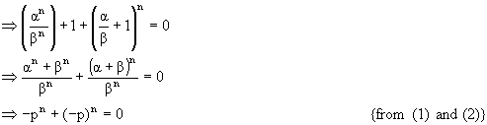
This is true only if n is an even integer.
Q-3: Show that the equation
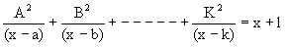 has no imaginary roots,
Where A, B, C---------K, a, b, c------k and l are real.
Solution: Assume a+ib is an imaginary root of the given equation then conjugate of this root a-ib is also root of this equation.
Putting x = a+ib and x = a-ib in the given equation then,
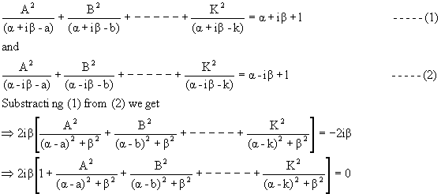
The expression in bracket 0
2ib = 0 b = 0 (because i 0)
Hence all roots of the given equation are real.
Q-4: Solve in
Solution:
The A.M of x+3, x-1 is 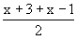 , i.e. (x+1)
Put x+1 = y then x+3 = y+2, x-1 = y-2
The equation becomes
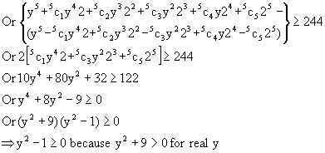
The corresponding equation =0 has roots 1, -1.
The sign scheme of y R is as follows.
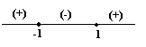
Fig (13)
y²-1, 0 holds if y -1 or y 1
Now y -1 x+1 -1 or x -2
y 1 x+1 1 or x 0
Hence x -2 or x 0
Therefore the solution set =.
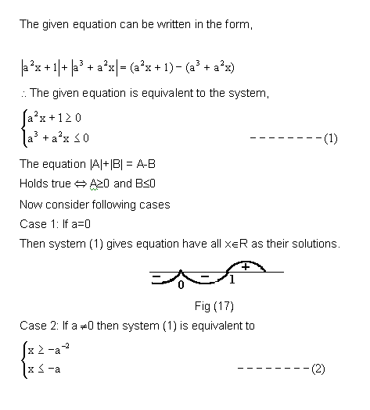
Q-5: let a, b, c be real, if has two real roots a and b where a< -1 and
b >1 then show that 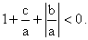
Solution:
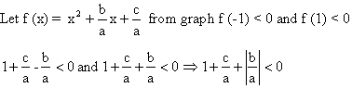
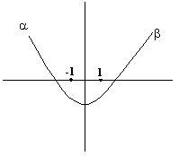
Fig (14)
Q-6: If a<b<c<d prove that the equation (x-a) (x-c) + k (x-b) (x-d) = 0 has real roots for all k R.
Solution:
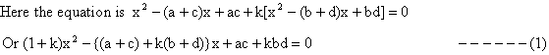
Equation (1) will have real roots if,
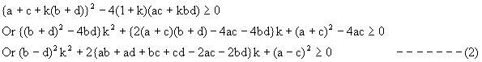
Now the discriminant of the equation corresponding (2) is,
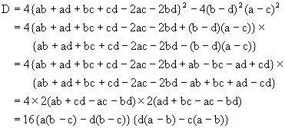
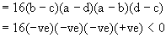
Because a<b<c<d
Also (b-d)2>0 so (2) is true for all k R.
Hence given equation have real roots.

Hard
Q-1: If p be the first of n arithmetic means between two numbers and q be the first of n harmonic means between the same two numbers, prove that q cannot lie between
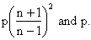
Solution: Let the numbers be x, y. Let the n AMs between them be A1, A2, -------- An
Then y = (n+2) th term = x + (n+1) d (d being the common difference)
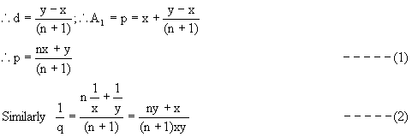
Equation (1) Þ y = (n+1) p-nx putting this in (2).
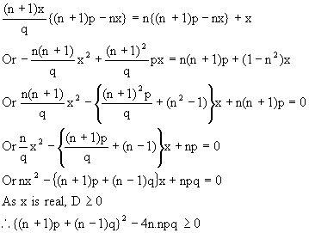
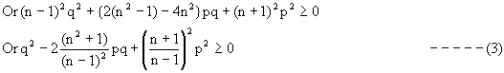
The corresponding equation in q is
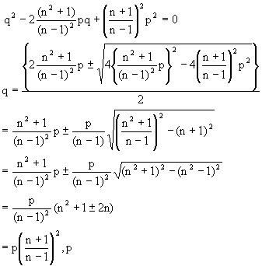
The sign scheme for (3) is as shown
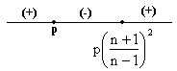
(3) q can not lie between
Subsequently:
a) If a>1 then system (2) has no solutions, and therefore the original equation has no solution.
b) If a=1, then system (2) has only unique solution i.e. x= -1 and the conditions of the original equation are not satisfied. Hence the original equation has no solution.
c) If 0<a<1 then -1<-a<0 and therefore the interval [-a-2, -a] contains no less than four integers provided the inequality -a-2£ -4 holds true. Now solve the system.
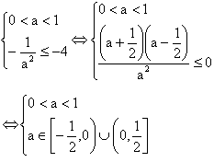
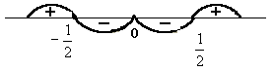
Fig (16)
Thus 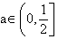, then the given equation has no less than four different integer solutions.
d) If -1<a<0 then 0<-a<1 and therefore the interval [-a-2, -a] contains no less than four integer provided the inequality -a-2 £ -3 holds true. Now solve the system.
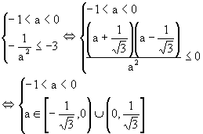
Thus 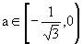, then the given equation has no less than four different integer solutions.

Q-2: Find all values of a for which the equation has no less than four different integer solution.
Solution: The given equation can be written in the form,
The given equation is equivalent to the system,
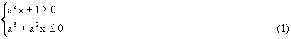
The equation |A|+|B| = A-B
Holds true A 0 and B 0
Now consider following cases
Case 1: If a=0
Then system (1) gives equation have all xÎR as their solutions.

Fig (17)
Case 2: If a ¹0 then system (1) is equivalent to
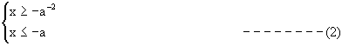
Now,
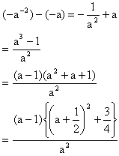
For a<1, a 0
-a-2+a<0
For a=1
-a-2+a=0
For a>1
-a-2+a>0
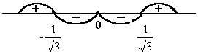
Fig (18)
e) If a= -1 then the interval [-1, 1] contains only three integer i.e. condition of the problem are not satisfied.
f) If a<-1 then -1<-a-2<0 and therefore the interval [-a-2, -a] contains no less than four integers. It is necessary that the inequality –a ³ 3 hold true thus for a £ -3 the given equation has no less than four integer solutions.
Combining all the results we get the set of required values for a,
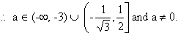
Q-3: Solve for x
Solution:
Here,
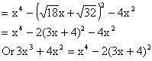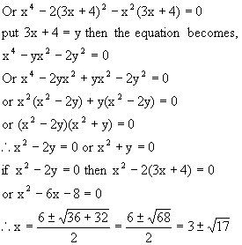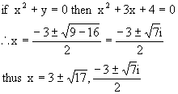

KEYWORDS
- Quadratic
- Root
- Discreminant
- Polynomial
- Coefficient
- Common roots
- Lagrange’s Identity
- Cauchy Swartz Inequality
- Multiplicity

